# Database Management System Lab KCS-551

## Bachelor of Technology

#### in

**Computer Science and Engineering**



**Submitted To: Submitted By:**

**MR. PUNIT KR. CHAUBEY RAVI PRAKASH**

**(Assistant Professor ) 2204220109027**

**( CSE , BIET, Lucknow ) CSE , Sec-3 B**

**Bansal Institute Of Engineering and Technology**

**Lucknow**

**(Dr. A.P.J. Abdul Kalam Technical University, Uttar Pradesh)**

## INDEX

|  |  |  |  |  |
| --- | --- | --- | --- | --- |
| SR.NO. | Experiment Name | Page No. | Date | Teacher’s Sign |
|  |  |  |  |  |
|  |  |  |  |  |
|  |  |  |  |  |
|  |  |  |  |  |
|  |  |  |  |  |
|  |  |  |  |  |
|  |  |  |  |  |
|  |  |  |  |  |
|  |  |  |  |  |
|  |  |  |  |  |
|  |  |  |  |  |

**Experiment No – 01**

#### **AIM:** Installation of MySQL

**Step 1**: Make sure you already downloaded the MySQL mysql-installer-web- community-8.0.34.0.msi file. Double click on the .msi file.

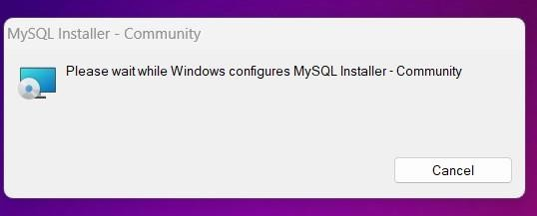

**Step 2 :**This is mysql-installer-web-community-8.0.34.0.msi. The setup wizard will install mysql-installer-web-community-8.0.34.0.msi on your computer. To continue, click **next.**Choose the setup type that best suits your needs. For common program features select **Full** and it’s recommended for general use. To continue, click next.

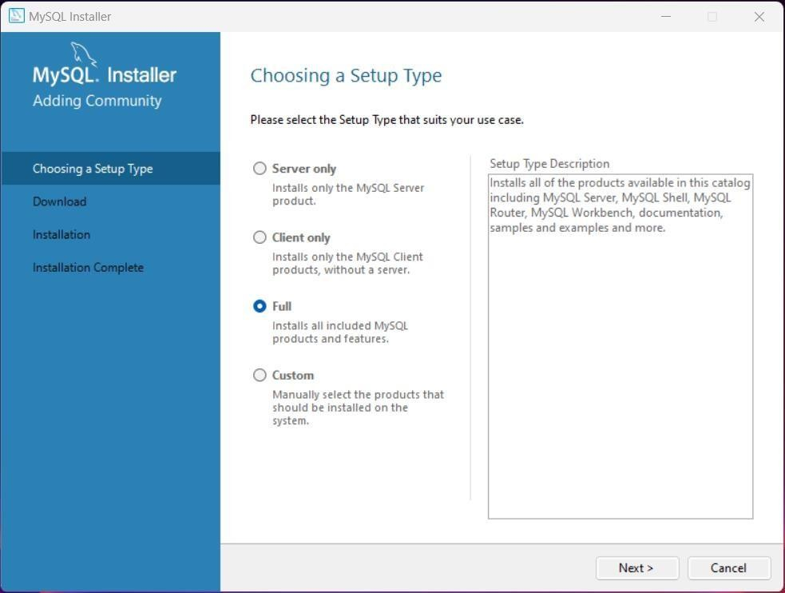

**Step 3 :** This wizard is ready to begin download. Destination folder will be in C:\Program Files\MySQL\ MySQL Server 8.0 To continue, click next.

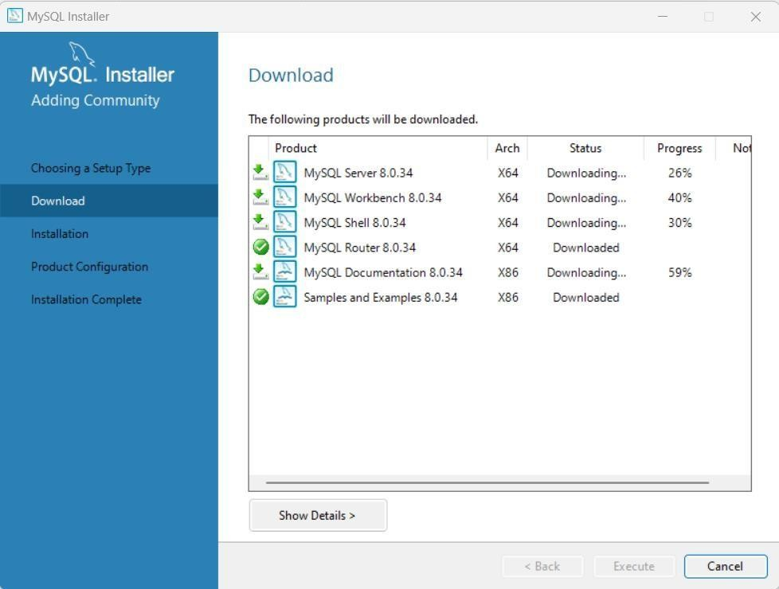

**Step 4 :** The program features you selected are being installed. Please wait while the setup wizard installs MySQL 8.0. This may take several minutes.Click on next .

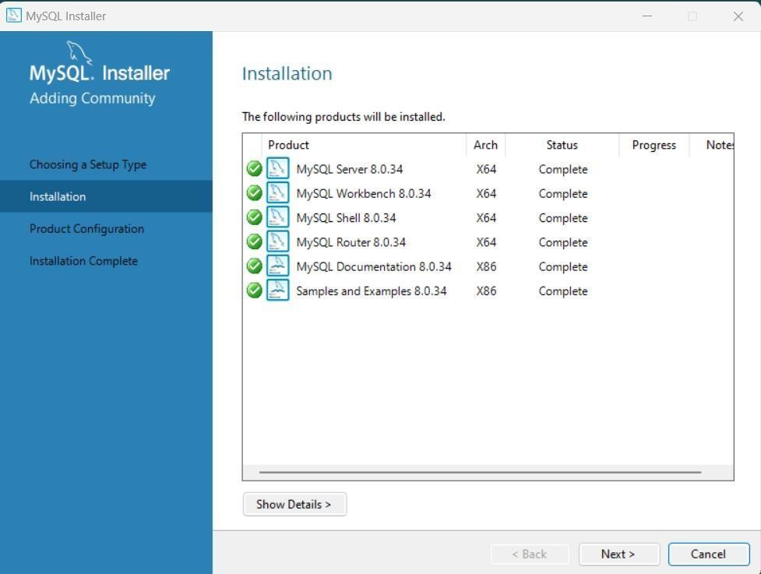

**Step 5 :** To continue, click next until you get this page. Please set the security options by entering the root password and confirmretype the password. continue, click next.

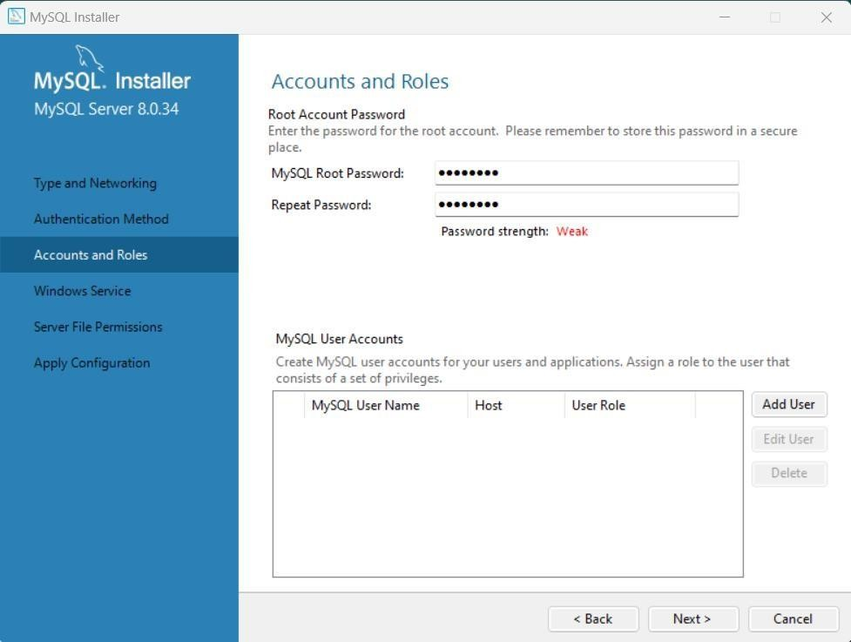

**Step 6 :** Select a standard configuration and this will use a general purpose configuration for the server that can be tuned manually. To continue, click next.

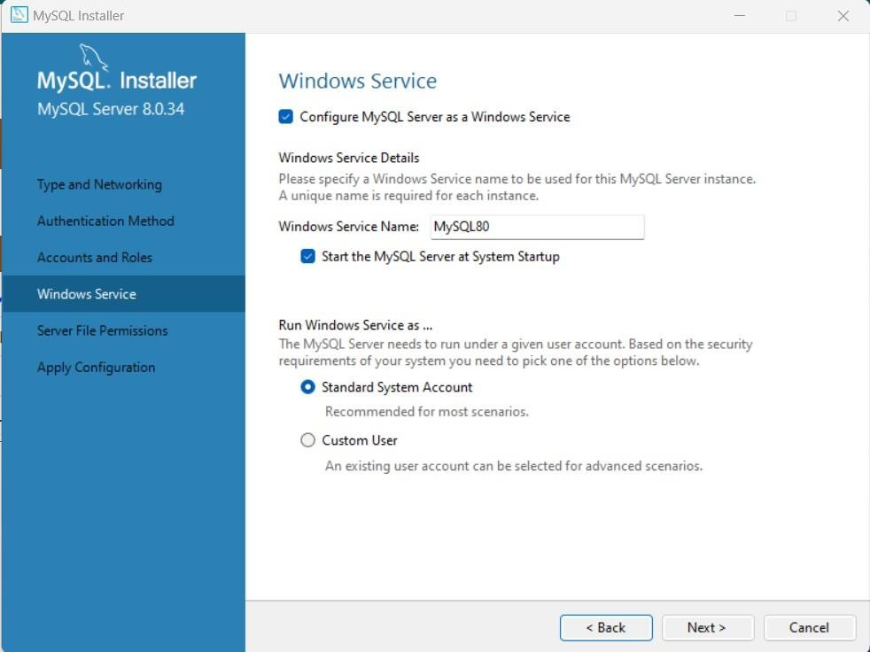

**Step 7:** To continue, click next.

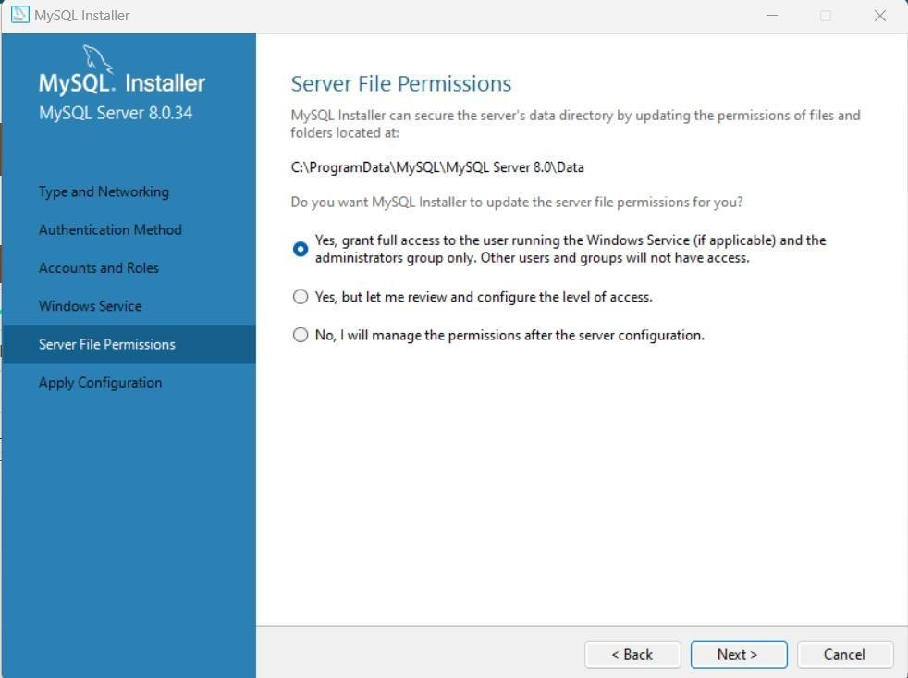

**Step 8 :** Configuration file created. Windows service MySQL 8.0.34 installed. Press finish to close the wizard .

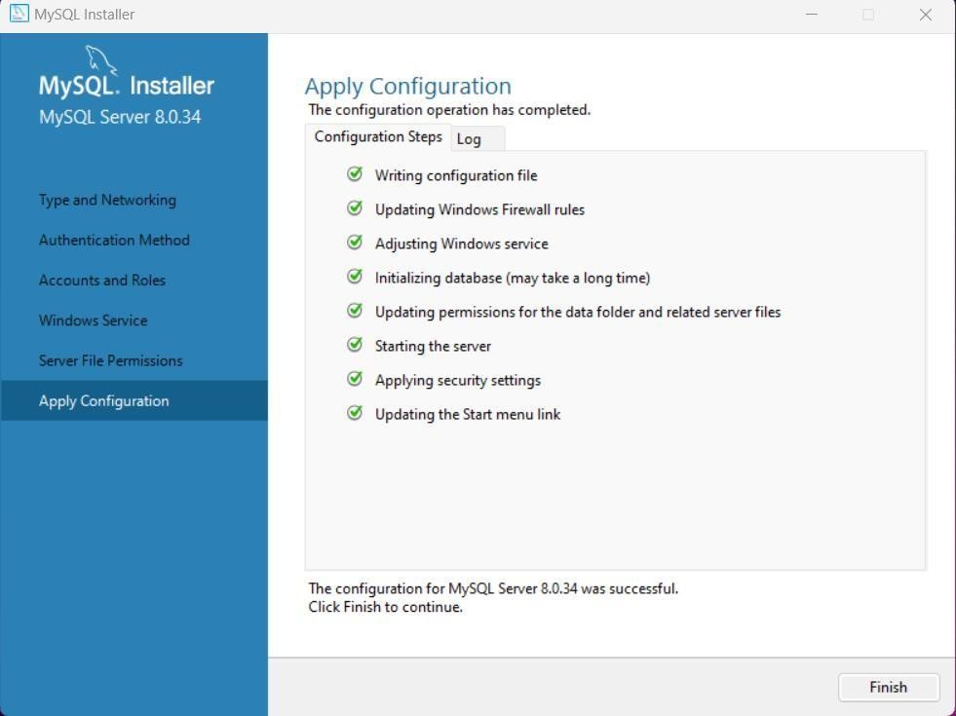

**Step 9 :** Windows service MySQL 8.0.34 installed. Press finish to close the wizard .

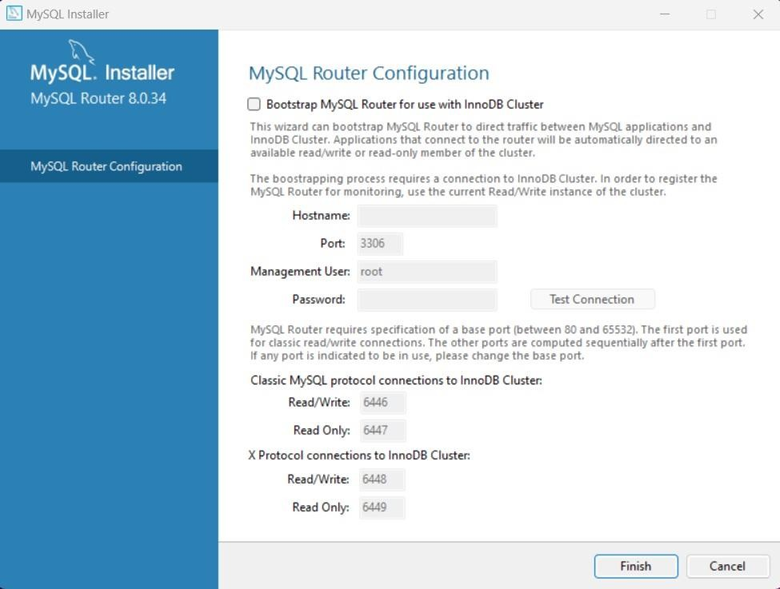

**Step 10:** Enter the MySQL Password and click on check and then click on next button to continue .

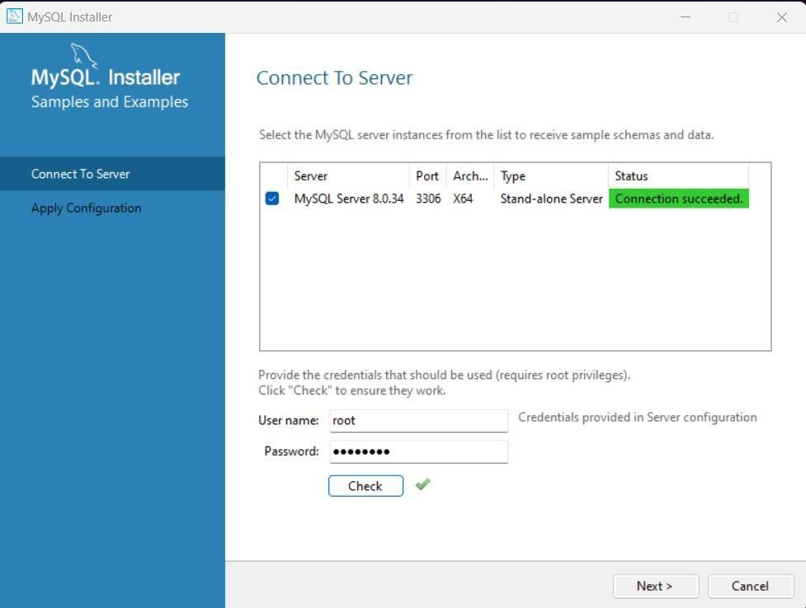

**Step 11:** Enter the new connection name and click on OK then close the tab.

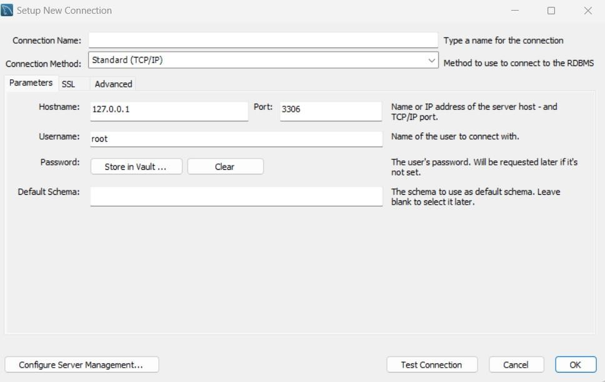

**Step 12 :** Open MySQL 8.0 Command Line Client and let’s ready for work on MySQL Server 8.0.34.

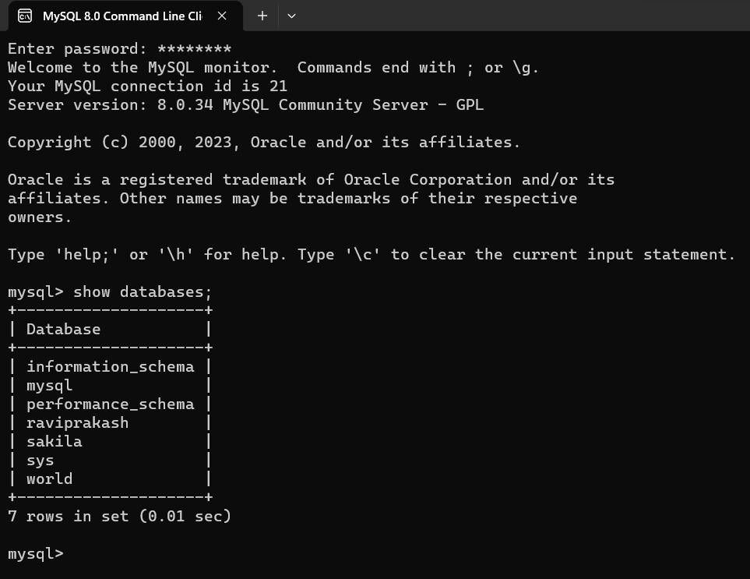

## Experiment No – 02

**AIM:** Creating Entity-Relationship Diagram usingcase tools.

### HOSPITAL MANAGEMENT SYSTEM

#### **Step1:** First of all we need to choose the number of entities (object with physical existence or conceptual existence)

* In hospital management system there are 3 major entities:

#### Doctors

* + Patients

#### Medicine

**Step2:** We should write the attributes associated with each entity.

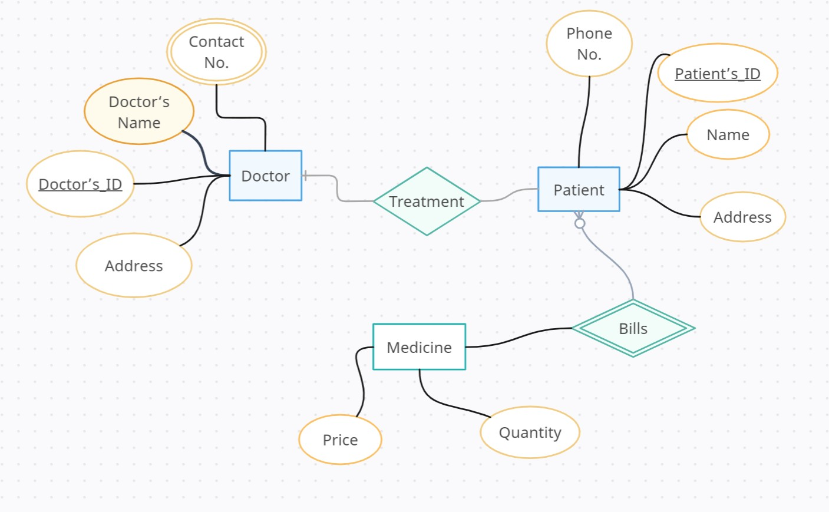

Fig: Entity- Relationship Diagram

**DATABASE MANAGEMENT CASE Tools**

**CASE (Computer-Aided Software Engineering) Tools**

CASE (Computer-Aided Software Engineering) packages are software packages that include many tools that can be helpful when it comes to database design. The main goal of these packages is to give designers a way of representing systems that are too complex to understand in their source code or schema-based forms. They help automate software development and maintenance tasks and usually contain tools for system analysis, project management, and design..

**Uses in Databases**

CASE tools can serve many functions in database design, including:

1. Collecting and analyzing data.

2. Designing a data model.

3. Feasibility analysis.

4. Requirements definition.

5. Implementing the database.

6. Prototyping.

7. Data conversion.

8. Generating application code.

9. Generating reports.

10. Programming and testing.

11. Maintenance.

**Advantages and Disadvantages**

CASE tools can provide many advantages when used in database design, including:

1. Improved productivity in development

2. Improved quality through automated checking

3. Automatic preparation and update of documentation

4. Encouragement of prototyping and incremental development

5. Automatic preparation of program code from requirements definition

6. Reduced maintenance systems

## 

## Experiment No – 03

**AIM: Prepare Sample Data To Practice SQL Skill.**

**Table1: Worker.**

CREATE TABLE worker(worker_id INT PRIMARY KEY AUTO_INCREMENT, first_name VARCHAR(30), last_name VARCHAR(30), salary INT, joining_date DATE, department VARCHAR(20));

INSERT INTO worker (first_name, last_name, salary, joining_date, department) VALUES ("Monika", "Arora", 100000, "2014-02-20", "HR"),

("Niharika", "Verma", 80000, "2014-06-11", "Admin"),

("Vishal", "Singhal", 300000, "2014-02-20","HR"),

("Amitabh", "Singh", 500000, "2014-02-20", "Admin"),

("Vivek", "Bhati", 500000, "2014-06-11", "Admin"),

("Vipul", "Diwan", 200000, "2014-06-11", "Account"),

("Satish", "Kumar", 75000, "2014-01-20", "Account"),

("Geetika", "Chahuan", 90000, "2014-04-11", "Admin");

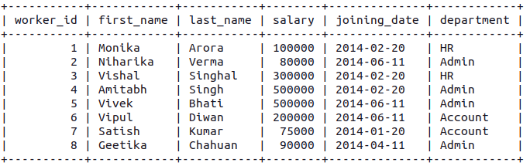

**Table 2: Bonus**

CREATE TABLE bonus(worker_ref_id INT, FOREIGN KEY (worker_ref_id) REFERENCES worker(worker_id), bonus_date DATE, bonus_amount INT);

INSERT INTO bonus VALUES (1, "2016-02-20", 5000),

(2, "2016-06-11", 3000),

(3, "2016-02-20", 4000),

(1, "2016-02-20", 4500),

(2, "2016-06-11", 3500);

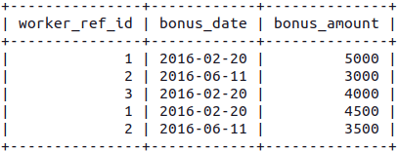

**Table3: Title**

CREATE TABLE title(worker_ref_id INT, FOREIGN KEY (worker_ref_id) REFERENCES worker(worker_id), worker_title VARCHAR(20), affected_from DATE);

INSERT INTO title VALUES(1, "Manager", "2016-02-20"),

(2, "Executive", "2016-06-11"),

(8, "Executive", "2016-06-11"),

(5, "Manager", "2016-06-11"),

(4, "Asst. Manager", "2016-06-11"),

(7, "Executive", "2016-06-11"),

(6, "Lead", "2016-06-11"),

(3, "Lead", "2016-06-11");

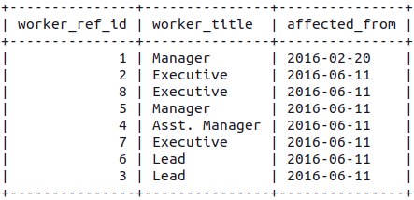

# Queries

**Q-1.** Write an SQL query to fetch “FIRST_NAME” from Worker table using the alias name as .

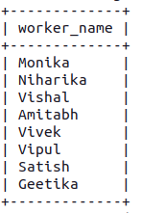

Q-2. Write an SQL query to fetch “FIRST_NAME” from the Worker table in upper case.

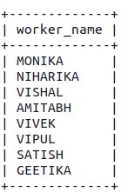

Q-3. Write an SQL query to fetch unique values of DEPARTMENT from the Worker table.

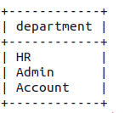

Q-4. Write an SQL query to print the first three characters of FIRST_NAME from the Worker table.

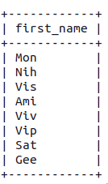

Q-5. Write an SQL query to find the position of the alphabet (‘a’) in the first name column ‘Amitabh’ from the Worker table.

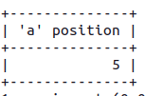

Q-6. Write an SQL query to print the FIRST_NAME from Worker table after removing white spaces from the right side.

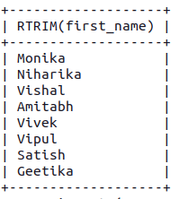

Q-7. Write an SQL query to print the DEPARTMENT from Worker table after removing white spaces from the left side.

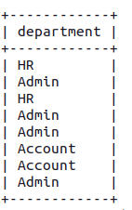

Q-8. Write an SQL query that fetches the unique values of DEPARTMENT from Worker table and prints its length.

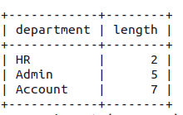

Q-9. Write an SQL query to print the FIRST_NAME from Worker table after replacing ‘a’ with ‘A’.

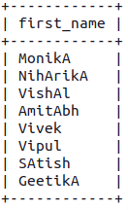

Q-10. Write an SQL query to print the FIRST_NAME and LAST_NAME from Worker table into a single column COMPLETE_NAME. A space char should separate them.

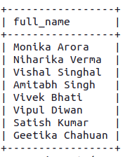

Q-11. Write an SQL query to print all Worker details from the Worker table order by FIRST_NAME Ascending.

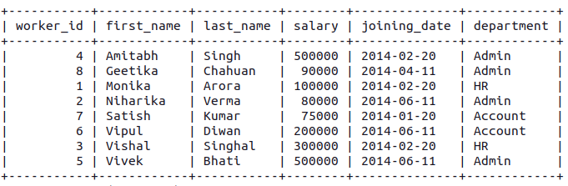

Q-12. Write an SQL query to print all Worker details from the Worker table order by FIRST_NAME Ascending and DEPARTMENT Descending.

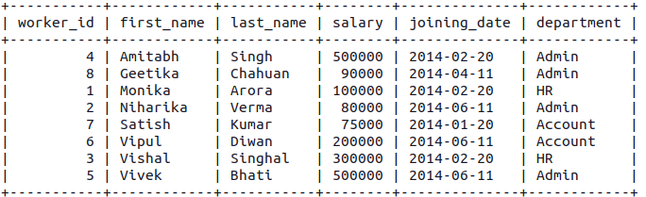

Q-13. Write an SQL query to print details for Workers with the first name as “Vipul” and “Satish” from Worker table.

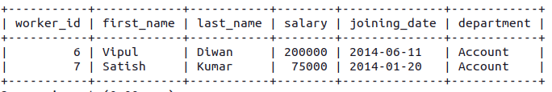

Q-14. Write an SQL query to print details of workers excluding first names, “Vipul” and “Satish” from Worker table.

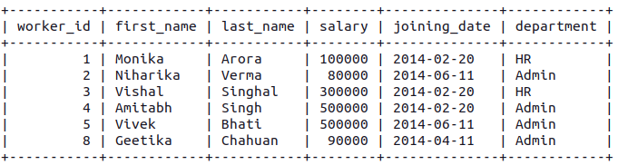

Q-15. Write an SQL query to print details of Workers with DEPARTMENT name as “Admin”.

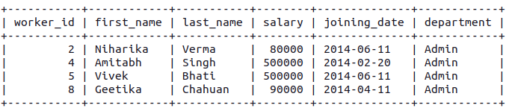

Q-16. Write an SQL query to print details of the Workers whose FIRST_NAME contains ‘a’.

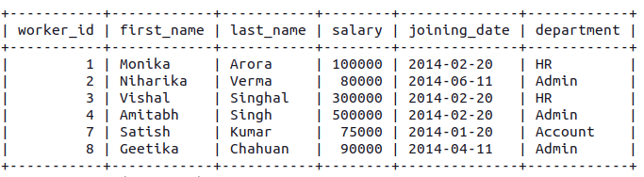

Q-17. Write an SQL query to print details of the Workers whose FIRST_NAME contains ‘a’.

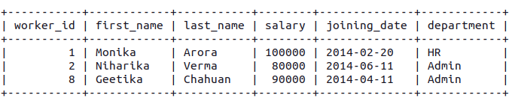

Q-18. Write an SQL query to print details of the Workers whose FIRST_NAME ends with ‘h’ and contains six alphabets.

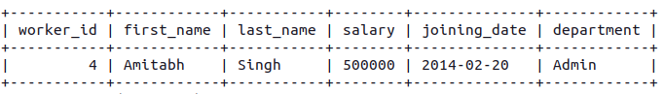

Q-19. Write an SQL query to print details of the Workers whose SALARY lies between 100000 and 500000.

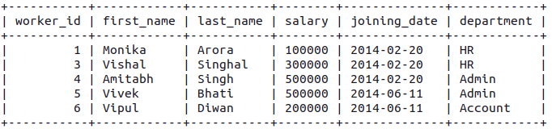

Q-20. Write an SQL query to print details of the Workers who have joined in Feb’2014.

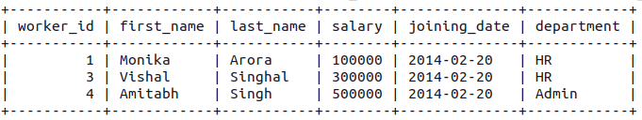

Q-21. Write an SQL query to fetch the count of employees working in the department ‘Admin’.

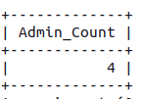

Q-22. Write an SQL query to fetch worker names with salaries >= 50000 and <= 100000.

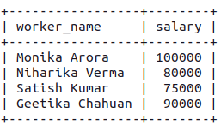

Q-23. Write an SQL query to fetch the no. of workers for each department in the descending order.

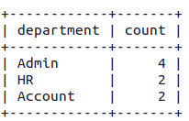

Q-24. Write an SQL query to print details of the Workers who are also Managers.

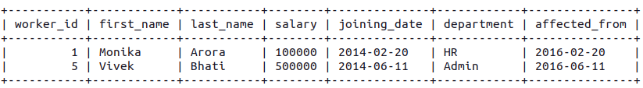

Q-25. Write an SQL query to fetch duplicate records having matching data in some fields of a table.

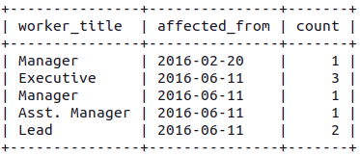

26. Write an SQL query to show only odd rows from a table.

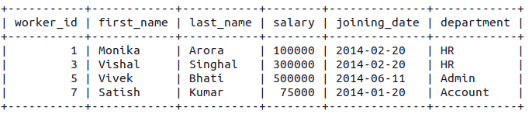

27. Write an SQL query to show only even rows from a table.

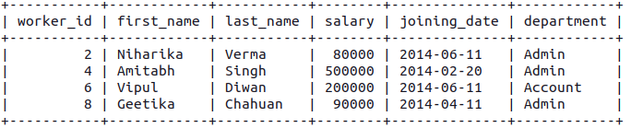

28. Write an SQL query to clone a new table from another table.

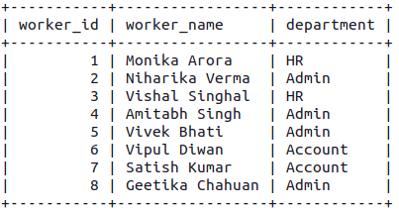

29. Write an SQL query to fetch intersecting records of two tables.

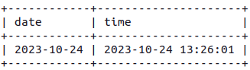

30. Write an SQL query to show records from one table that another table does not have.

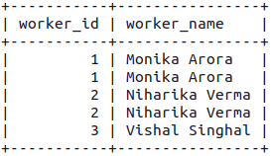

31. Write an SQL query to show the current date and time.

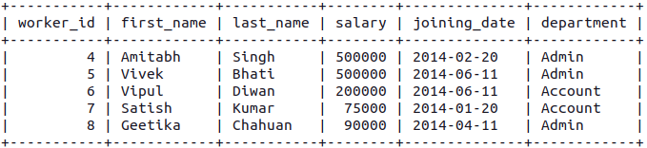

32. Write an SQL query to show the top n (say 10) records of a table.

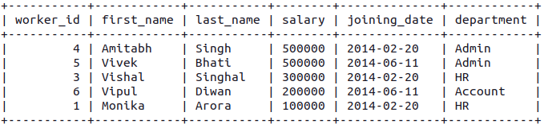

33. Write an SQL query to determine the nth (say n=5) highest salary from a table.

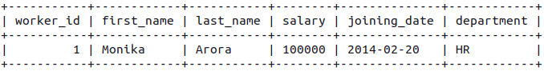

34. Write an SQL query to determine the 5th highest salary without using TOP or limit method.

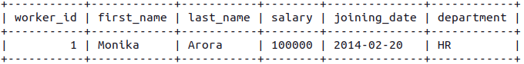

35. Write an SQL query to fetch the list of employees with the same salary.

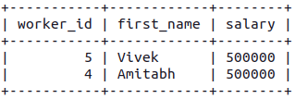

36. Write an SQL query to show the second highest salary from a table.

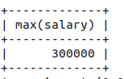

37. Write an SQL query to show one row twice in results from a table.

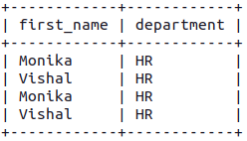

38. Write an SQL query to fetch intersecting records of two tables.

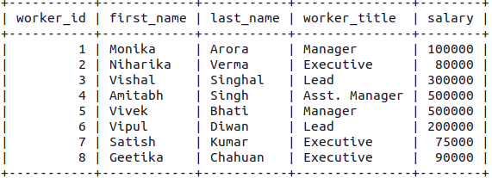

39. Write an SQL query to fetch the first 50% records from a table.

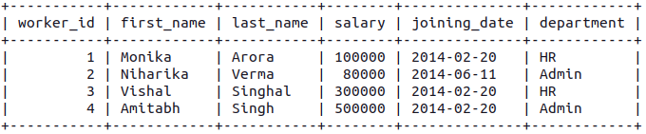

40. Write an SQL query to fetch the departments that have less than five people in it.

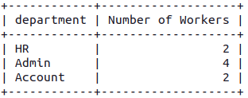

41. Write an SQL query to fetch the departments that have less than five people in it.



42. Write an SQL query to show the last record from a table.

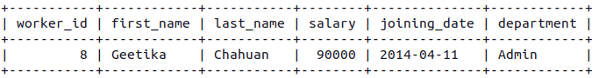

43. Write an SQL query to fetch the first row of a table.

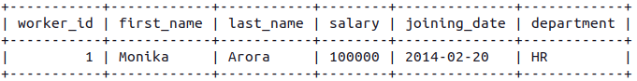

44. Write an SQL query to fetch the last five records from a table.

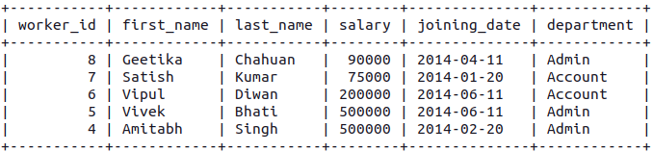

45. Write an SQL query to print the name of employees having the highest salary in each department.

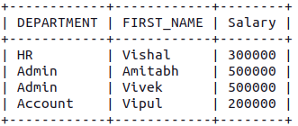

46. Write an SQL query to fetch three max salaries from a table.

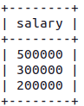

47. Write an SQL query to fetch three max salaries from a table.

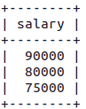

48. Write an SQL query to fetch three max salaries from a table.

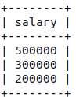

49. Write an SQL query to fetch departments along with the total salaries paid for each of them.

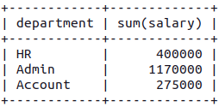

50. Write an SQL query to fetch the names of workers who earn the highest salary.

